Urban Eats ERP – Company Background and Round 1 Interview Notes
Prepared by: Ho Kim Yen Lu, Business Analyst · Version 1.1 · 29 Oct 2026 · Status: Draft for internal use

1. Purpose
This document records the company context and the first round of discovery interviews for the Urban Eats ERP project. It captures what stakeholders said and what the interviewer observed, without analysis.
It is the input to the Stakeholder Analysis and Issues Log (document 2). Statements have not yet been validated; where stakeholders contradict each other, both views are recorded as said.

2. Company background
Urban Eats Café Group runs 6 cafés across Sydney, turns over about AUD 6.2M a year and employs about 85 staff, mostly casuals. The owner, Jennie, founded it in 2018 and plans to open 4 more outlets by the end of 2028. She believes the business has outgrown its patchwork of systems.
The outlets are split into two areas:
Area | Area manager | Outlets | Notes
North | Raymond | CBD, Marsfield, Newtown | CBD is the busiest outlet (about AUD 1.6M/yr), managed by Daphne
West | Hailey | Parramatta, Blacktown, Penrith | Blacktown and Penrith were bought from another operator in 2024; Parramatta is managed by Brian

Current systems
Process | How it works today
Point of sale | Square at 4 outlets; Lightspeed at Blacktown and Penrith (inherited in 2024)
Rostering and timesheets | Deputy
Accounting and payroll | Xero, run by an external part-time bookkeeper
Purchasing | Each store manager orders directly from suppliers by phone, email or WhatsApp
Stock control | Paper count sheets, typed into Excel
Reservations | Phone, plus a paper diary or shared Google Sheet; varies by outlet
Delivery | Uber Eats and DoorDash tablets at all outlets; HungryPanda also at CBD and Marsfield
Management reporting | Each store manager emails an Excel summary every Monday

Jennie’s brief to the BA: “I want one system that runs the whole business. Sort out what we actually need.”

3. Organisation and interviewees
Five people were interviewed across three levels. Four of the six store managers were not interviewed in this round.
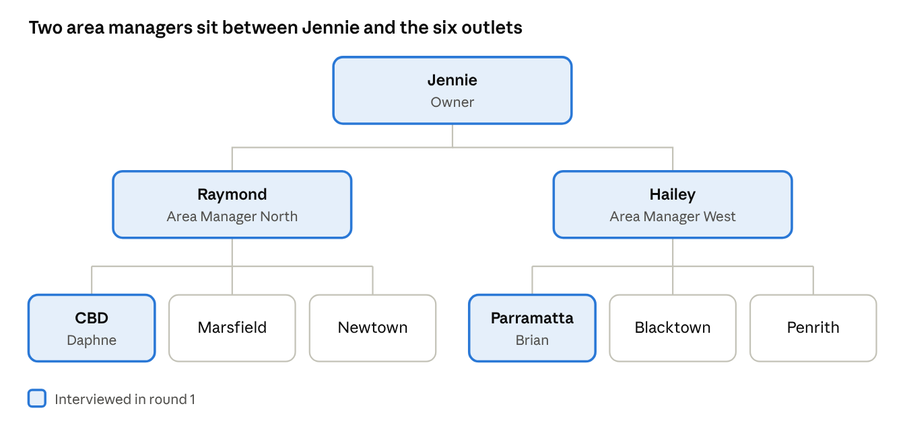
Reporting lines are formal. Who actually holds influence is assessed in the stakeholder analysis.

Interview log
# | Stakeholder | Date | Duration | Format and setting
1 | Jennie, Owner | Mon 19 Oct 2026, 9:00am | 45 min | In person, head office
2 | Raymond, Area Manager North | Tue 20 Oct 2026, 2:30pm | 30 min | In person, CBD outlet; two phone interruptions
3 | Hailey, Area Manager West | Tue 20 Oct 2026, 4:00pm | 50 min | Video call; Hailey screen-shared her Excel dashboard
4 | Daphne, Store Manager CBD | Thu 22 Oct 2026, 2:30pm | 25 min | In person, CBD back counter; interrupted three times
5 | Brian, Store Manager Parramatta | Fri 23 Oct 2026, 6:00am | 35 min | In person, Parramatta staff room before opening

Interview 1: Jennie, Owner
Founder and sole owner. Approves budget and makes final decisions. Project sponsor.

Key statements (verbatim)
- “I find out how a month went three weeks after it ends. By then it’s too late to do anything.”
- “Every Monday I get six spreadsheets and none of them add up to the same number. Raymond’s sales are always higher than what I see in the bank.”
- “I want one system. POS, stock, rosters, accounts, everything. Like what the big chains have.”
- “I need to know my food cost and wage cost per store, every week. Industry says food should be around 30%, I have no idea where we are.”
- “Stocktake is done weekly, so the stock data is there, it’s just on paper.”
- “I want to open four more stores. I can’t run ten stores like this.”
- “It has to be live before the end of June next year. That’s not negotiable.”
- “Managers should be able to see how they’re doing. I don’t want everyone seeing everything though.”
- “Maybe a loyalty app too. And online ordering. Customers keep asking.”

Interviewer observations
- Very clear on the pain; vague on what “done” looks like. Proposed a solution (“one system like the big chains”) within five minutes.
- Budget was not discussed.
- Called the end-of-June deadline “not negotiable” but did not say why.
- Did not say who should or should not see which numbers.

Interview 2: Raymond, Area Manager North
Area manager for CBD, Marsfield and Newtown. 20 years in hospitality, 4 at Urban Eats.

Key statements (verbatim)
- “No offence, but we’ve done this before. Systems come in, nobody uses them, they go away.”
- “My biggest number is wages. On Sundays, CBD is bleeding money with penalty rates.”
- “I approve every roster before it goes out. That’s how I keep wages under control, and I want to keep doing that.”
- “Deputy works. The staff know it. Don’t make me retrain eighty casuals.”
- “My sales are what Square says. If Jennie’s bank number is lower, that’s an accounting thing.”
- “CBD is not Penrith. CBD customers want the oat-milk matcha and the sourdough toastie. Each store needs its own menu.”
- “I’m in the car half the day. If it doesn’t work on my phone, I won’t use it.”
- “Keep it simple for the kids on the floor. They’re 19, they’re here for six months.”

Interviewer observations
- Sceptical for most of the interview; became engaged when discussing wages.
- “We’ve done this before” suggests a past system rollout failed. Not followed up.
- Reads sales straight from the Square dashboard.

Interview 3: Hailey, Area Manager West
Area manager for Parramatta, Blacktown and Penrith. 2 years at Urban Eats, previously a retail analyst.

Key statements (verbatim)
- “I built this dashboard myself. Revenue, average spend, labour %, refunds, week on week. It works, it just takes forever.”
- “Blacktown and Penrith are on Lightspeed. Nothing matches Square. A flat white is ‘FW Reg’ in one and ‘Flat White - R’ in the other.”
- “I want real-time. Why wait until Monday to find out Tuesday was bad?”
- “We should have one menu and one price list across all six stores. It’s one brand.”
- “Every manager should see every store’s numbers. A bit of competition is healthy.”
- “Refunds at Parramatta have nearly tripled lately. I’ve asked Brian twice. He says it’s delivery complaints.”
- “When I say sales I mean net, ex-GST, after refunds. Otherwise you’re comparing rubbish.”
- “Whatever we pick must export to Excel. I don’t trust dashboards I can’t check.”

Interviewer observations
- The most data-literate stakeholder and a likely ally.
- Did not say how long her Monday dashboard takes to build.
- Her views on menu, visibility and the meaning of “sales” differ from those of other interviewees.

Interview 4: Daphne, Store Manager CBD
Runs the busiest outlet, about 22 staff. 3 years in role; reports to Raymond.

Key statements (verbatim)
- “Please, I don’t need more reports. I need less admin.”
- “Sunday night is ordering night. Seven suppliers, every one different. Bakery is a phone call, dairy is email, veg is WhatsApp.”
- “We run out of oat milk and it’s a disaster. Half our coffees are oat.”
- “I know roughly what to order. I’ve been doing it three years.”
- “Rosters change every day. Someone’s sick, someone quits. If I have to wait for Raymond to approve every swap, I’m short on the floor.”
- “Stocktake? We do it when we can. End of month, mostly.”
- “Reservations are in the diary. Friday and Saturday we get no-shows, it’s annoying.”
- “If it needs more than three taps during the morning rush, nobody will use it.”

Interviewer observations
- Time-poor and protective of her time. Strong on day-to-day operations; least interested in reporting.
- Ordering quantities appear to be based on her experience rather than a written method. Not followed up.
- Mentioned in passing that food is thrown out at close; quantity not discussed.

Interview 5: Brian, Store Manager Parramatta
Runs Parramatta, about 14 staff. 8 months in role, promoted from shift lead; reports to Hailey.

Key statements (verbatim)
- “Delivery is killing us. Uber and DoorDash orders come in on tablets and I type them into Square by hand so they show up in sales.”
- “The refunds are mostly delivery complaints. Cold food, missing items. I think.”
- “The cash drawer is short most nights. Twenty, fifty bucks. I count it on paper at close.”
- “We do a lot of office orders around here, platters for meetings. That’s been growing.”
- “Hailey’s dashboard makes us look bad because of the refunds.”
- “I’d like to see what the other stores do, how they handle things. Nobody really trained me.”
- “Honestly, anything is better than what we have.”

Interviewer observations
- Keen but nervous. Became uncomfortable and changed the subject when refunds came up.
- Re-keys delivery orders into Square by hand. Unknown whether other outlets do the same.
- Did not explain how office orders are taken, recorded or invoiced.
- New in role; could become a strong user champion if well supported.

Requirement
- Complete the stakeholder analysis and issues log (document 2).
- Schedule round 2 follow-up interviews, plus interviews with stakeholders not yet consulted.
- Agree Phase 1 scope and priorities with the sponsor, then draft the BRD.

